**Assignment Cover Sheet**

To be completed **electronically** by the student and submitted with each piece of work. Please upload this completed cover sheet via Turnitin

**Assignment Title:** 2D Game Design

**Tutor:** Ms. Zainab Muhammad Aslam

**Student Name**: Angela Joy S. Sto Domingo

**Date of Submission**: 21/01/2024

**Details of your submission:** Google drive has the assets I used. Included a link to my game in Itch.io.

For an online submission, please enter the URL of where your project files can be accessed (e.g. Google Drive). If a physical artefact, please provide further details on how this project has been submitted to tutors.

|  |
| --- |
| Google Drive: https://drive.google.com/drive/folders/1Syn1h_k25hqYv35GNdpoxTIvWdiUt1To?usp=sharing  Itch.io link: https://angelasd.itch.io/endless-depths |

In submitting this assignment, I am confirming that I have read and understood the regulations for assessment, and I am aware of the seriousness with which the University regards unfair practice. Please see the universities [Unfair Practice Policy](https://thehub.bathspa.ac.uk/reference/student-policies/unfair-practice-policy) for details.

Signed: Angela Joy S. Sto Domingo Date: 21/01/2024

**Documentation**

* **Title:** Endless Depths
* **Abstract: A brief synopsis of your game concept, describing key game mechanics and gameplay.**

My game concept is simple, straightforward and is up to par to my skill level with C# and Unity. I took inspiration from infinite platformer games, like Canabalt and Geometry Dash. Their game concepts are so simple, yet addictive, so I decided to try that formula out with my game, except of course, mine is vastly different from the aforementioned games.

I introduce to you: Endless Depths. This is a 2D infinite pixel platformer game where the protagonist must evade incoming sea monsters to try and escape the ocean and survive for as long as possible. You’ll only need the top and bottom arrows to control your character. Just like the game Flappy Bird, you won’t actually win anything / escape the ocean and live happily ever after on land (Although there is a level 2, but you would have to survive a long time to reach that point).

This is a strategic and fast-paced game, so you would need to think and move fast before an enemy hits you. You only have one life, so try to have fast reflexes while playing this game.

* **Game rules: A description of the rules, and game structure you have chosen and why you have made those choices.**

Just like I mentioned earlier, the rules are simple and straightforward. You only need to dodge the enemies swimming towards you. Fortunately, you are small enough (A.K.A you have a smaller hitbox) than them, so you should have no problem dodging most of them with the top and bottom arrows on the keyboard. Sometimes, the game spawns a horde of enemies at once, where you have little room to escape in, but I kept that in to make it even harder for the player to progress to level 2. It not only helps the player improve their sense of urgency and decision-making, it also helps them develop precision in control input. You cannot simply press the top and bottom arrows to win; you would need to focus and anticipate the enemies, and gradually adjusting your character to avoid the enemies.

Since this is a challenging game, I decided to put easy-listening and copyright-free 8bit music in the background to lessen the player’s tension and stress while playing it.

I added these choices to my game because of my limited knowledge about C# and Unity in general, so I decided to make a simple game that showcases what I know about developing a game in Unity.

* **Context: Evidence of any games, of a similar style or genre, that have inspired your game design.**

I have been playing Subnautica lately, so I’ve taken some inspiration from it and decided to make my game water themed. I’ve chosen to make Subnautica an inspiration for my game because I think it has an original idea where it also takes place in the vast never-ending ocean full of large sea animals in which you must avoid at all costs. You also have to survive for as long as possible where you have to always mind your surroundings, health, water levels, and hunger. I then decided to implement that premise into my 2D platformer game, which takes the concept of Subnautica and waters it down a great amount to the point where you would only need to press the top and bottom arrows on the keyboard to avoid colliding into sea monsters.

Since I can’t only have Subnautica as my main inspiration game (as it is an open-world video game where you can pretty much go anywhere and do anything), I’ve also revisited Mario games. I’ve taken note of those water levels, where Mario swims through water and tries to survive without dying to enemies until you reach the finish line.

I will admit that I was originally going to make a runner game just like Canabalt and Geometry Dash, but I figured that we’ve already got enough of those already on the market, so I decided to make mine different from those games. Why not swim instead of running? You do not see that very often.

* **Evidence of design and prototyping, testing and feedback: This should include concept artwork, character design, level design, narrative design etc. (and this should include: screenshots, paper prototypes, photos and or videos) test plan, test data and evidence of testing (e.g. screenshots, photos and or videos).**

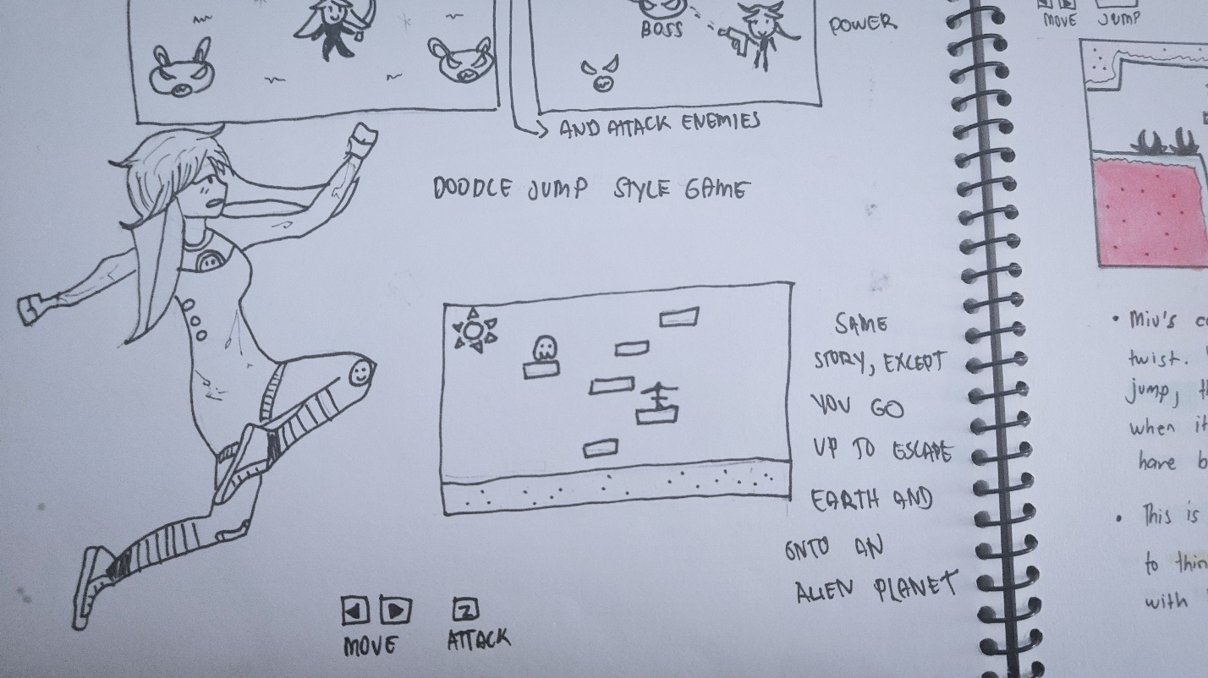



These were the early stages of my game. It was going to have a human rabbit girl running and jumping through obstacles. I was still learning how to animate at this point, so I didn’t have much knowledge about what resolution and size I should make this character in for it to look good in Unity, so I unfortunately scrapped this idea and went to get free assets instead. It still worked in my favor since I wouldn’t have come up with the infinite swimmer idea if I had gone in making my own assets for the game.



Source: https://craftpix.net/freebies/octopus-jellyfish-shark-and-turtle-free-sprite-pixel-art/?num=1&count=35&sq=fish&pos=6



Source: <https://craftpix.net/freebies/free-swimming-characters-animation-pixel-art/?num=1&count=18&sq=swim&pos=3>

The human girl is the character you’re controlling, and the octopus is just one of the six enemies appearing in the game.

I’ve given the full game to my friends and families, and I’ve received criticisms about some enemies spawning in huge hordes (which makes the game unfair, as sometimes you won’t have enough time to escape from them) and some enemies overlapping each other sometimes. Since my knowledge about C# and Unity is limited, I was only able to fix the part where the enemies spawn in huge numbers. The game should still be playable, even if the enemies overlap each other.

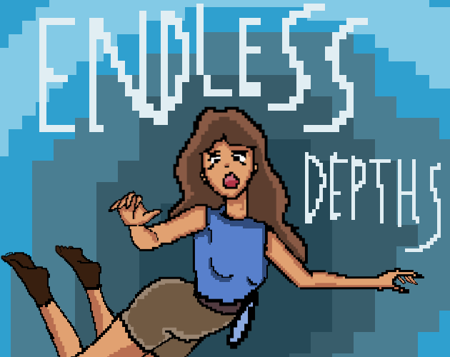

The cover art I made.

Since I was using free assets, I had to compensate for it somehow, so I made this cover art for the game. It depicts the protagonist in panic underwater.

**Technical Description: A description of any of the key techniques or technical challenges you have encountered in developing your game.**

During the development of this game, I ran into issues of the game sometimes lagging, so I implemented this system using C# and Unity’s tools where it would destroy game objects that the player has already dodged from, to prevent the game from slowing down even further. I have also adjusted the hitboxes of the enemies so that the player doesn’t die so easily just from touching a hair of their sprite. I also ran into issues of the enemies’ sprites not playing their animation when swimming towards the player, so I created prefabs out of them and it worked, plus I could also re-use those prefabs to spawn multiples of them.

**Critical Reflection: An open and detailed evaluation of your game that notes what is compelling about the work, what could be improved, and what you need to learn to make these improvements.**

I think what’s unique about my game is that you barely see games that are set underwater, so I think I made the right decision to make mine take place in a deep sea. I also made the right call to make the game as simple as possible, so that I don’t get overwhelmed developing it, considering how limited my knowledge is about C# and using Unity’s complex tools.

There are definitely a lot of glaring issues in my game. I had not noticed when I uploaded the game on Itch.io, the main menu image doesn’t cover the rest of the screen, which was my fault for not checking it before building the project. The entire game also feels a bit unfinished. At the time, I did not know what features I could’ve added. I should’ve added a high score, a smooth transition between scenes, and made my UI buttons just a bit more interactive. The criticism I got about the enemies overlapping each other is also present in the game.

Moving forward, I plan to learn more about game development, and especially the C# language, so I know what to do with the future games I plan to make. This is a first game I’ve ever developed, and I hope you enjoy it at least a bit, despite the issues present in the game.

**Bibliography and references: A bibliography listing any games, films, texts etc. that have inspired your game. Your Game Design Document should be fully referenced.**

* Miyamoto, Shigeru. Super Mario Bros. Nintendo, 1985. Video Game.
* Unknown Worlds Entertainment. Subnautica. Unknown Worlds Entertainment, 2018. Video Game.
* Saltsman, Adam. Canabalt. Semi Secret Software, 2009. Video Game.
* RobTop. Geometry Dash. RobTop, 2013. Video Game.
* Halfbrick Studios. Jetpack Joyride. Halfbrick Studios, 2011. Video Game.
* Background Underwater Image: Created by Ansimuz, sourced from <https://ansimuz.itch.io/underwater-fantasy-pixel-art-environment>
* Enemy sprites: Sourced from <https://craftpix.net/freebies/octopus-jellyfish-shark-and-turtle-free-sprite-pixel-art/?num=1&count=35&sq=fish&pos=6>
* Player sprite: Sourced from <https://craftpix.net/freebies/free-swimming-characters-animation-pixel-art/?num=1&count=18&sq=swim&pos=3>
* Main Menu Background Music: Best Friend (8bits), obtained from AnimeLive on YouTube.
* Game Background music: The Backyardigans: Castaways - 8 Bit Lofi Hip Hop, obtained from Tad on, on YouTube.
* Particle, and wooden panel: Made by Hooson, obtained from https://drive.google.com/file/d/1D66LinJqFeXfrzC6QdQpCz6JpWVcPsBy/view